

User Manual
DVTk Storage SCP emulator 5.1.0

A DVTk based tool

Document version 1.5
September 13, 2018

Table of Contents

1 Introduction 3
1.1 Revision History 3
1.2 General 3
1.3 System Requirements 3
1.3.1 Operating system 3
1.3.2 Software requirements 3
2 Software installation 5
2.1 Installation of DVTk Storage SCP emulator software 5
3 Functional description of the SCP emulator 6
3.1 Menu bar 6
3.2 Tool bar 7
3.3 Information screen selection 7
3.3.1 Storage SCP configuration 8
3.3.2 Storage Commitment configuration 9
3.3.3 SOP Class selection 10
3.3.4 Logging 11
3.3.5 Validation results 12
3.3.6 Store Files functionality 13
4 Supported DICOM SOP classes 16
5 Supported transfer syntaxes 20

Introduction

Revision History
Version | Date | Description
1.0 | October 2, 2007 | First version of this document, describing the functionality of DVTk Storage SCP Emulator version R3.0.0.
1.1 | March 13, 2008 | Releasing .NET2.0 version.
1.2 | June 16, 2009 | Releasing 3.2.0 version based on HLI.
1.3 | October 06, 2009 | Releasing 3.3.0 with new Store Files functionality.
1.4 | May 16, 2017 | Releasing version 5.0.0 based on .NET Framework 4.
1.5 | September 13, 2018 | Added new transfer syntaxes

General

The DVTk Storage SCP emulator application is used to receive DICOM part-10 files from a remote DICOM Storage SCU system. It can also respond to Storage commitment requests for the received dataset. The waiting time for sending the storage commitment response to the SCU is configurable in the SCP emulator.
Supported features of the Storage SCP emulator are:
- Configurable transfer syntax selection
- Configurable SOP class selection
- All received DICOM files will be written in DICOM part 10 format in a user selectable directory
- Possibility to create a DICOMDIR file for the received DICOM files

System Requirements

Operating system
The following operating systems are supported:
- Windows XP
- Windows 7
- Windows 8
- Windows 10

Software requirements
The following packages are required for the installation of the software packages:

- Microsoft .NET framework 4

The Microsoft .NET framework software package is included in the installer of the DVTk Storage SCP emulator tool.
See: http://www.dvtk.org for new versions and features.

Software installation

All the steps of the installation process are controlled by the DVTk Storage SCP emulator installer package. During the installation process, the installer will check if the Microsoft .NET Framework R2.0 is already installed on the system. If present, this step of the installation process will be skipped.

Installation of DVTk Storage SCP emulator software

- Download or copy the file Storage SCP.zip to a temp directory on the PC.
- Double click with the left mouse button on the Storage SCP.zip file and extract the file “Storage SCP Emulator.exe” to the temp directory.
- Start the installation procedure by double clicking with the left mouse button on the file Storage SCP Emulator.exe
- In the window “Microsoft .NET Framework 4 setup” select “ I agree” to accept the license agreement. Press “install” to start the installation process. At the end of the installation procedure press “OK”. The Microsoft .NET Framework 4 software is installed.
After the .NET Framework software is installed, the installer package continues with the installation of the Storage SCP Emulator software
- Follow the instructions in the installer window and accept the license agreement.
- After the button “install” is pressed, the installation will start. At the end, press the “Finish “button. The DVTk Storage SCP Emulator application is installed and ready for use.

In windows “All programs” there is an entry created “DVTK”. When selecting DVTK, a submenu with all installed DVTK applications will be opened. From this submenu the Storage SCP Emulator tool can be selected and started. There is also a shortcut created on the desktop

Functional description of the SCP emulator

In the screen capture below, the User Interface of the Storage SCP emulator tool is shown:

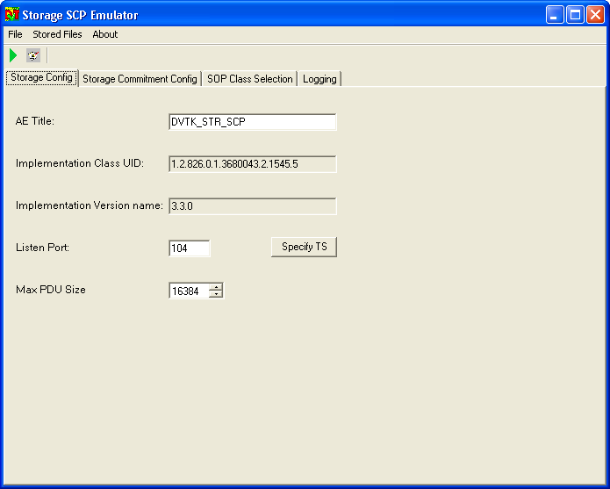

The Storage SCP emulator start up window contains the following sections:

Menu bar

From the Menu bar the following file options can be selected to control the Storage SCP emulator:

File:
- Run Emulator

- Stop Emulator

- Config File
  - Load
  - Save As

- Exit

Stored Files:

- Explore Validation Results…

- Explore Received DICOM Messages…

- Create DICOMDIR for Received DICOM Messages…

- Options…

About:

- About Emulator

Tool bar

The tool bar contains the following short keys to control the Storage SCP emulator process:
Start / Stop Emulator

By pressing this button the SCP emulator starts listening for incoming association requests for storage and storage commitment. Pressing this button again will stop the emulator.

Validation On/Off 

By pressing this button, the validation will be On/Off. When enabled, the emulator will perform a validation of the received DICOM messages and DICOM objects.

Information screen selection

The following screens can be selected for display

- Storage configuration

- Storage Commitment configuration

- SOP Class Selection configuration

- Log information

- Validation results (this screen is only present in case the option “Perform validation” is enabled).

Storage SCP configuration

In the Storage configuration screen, the parameters for the communication with the SCP as well as the behavior of the SCP emulator can be configured. The configuration parameters are as follows:

- AE title
AE title used by the SCP emulator

- Port number
Listen port of the Storage SCP emulator for incoming storage associations.

- Max PDU size
This is the Max PDU size proposed by the Storage Emulator SCP application to the SCU node. Default value is set to 16k

- Implementation Class UID
1.2.826.0.1.3680043.2.1545.5

- Implementation Class Version
3.3.0

- Specify transfer syntax

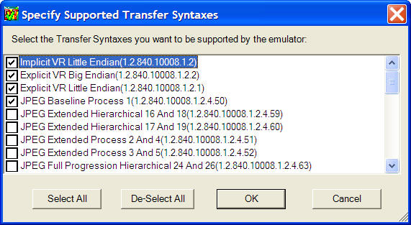

The user can select 1 or multiple transfer syntaxes for storage.
By default, the following transfer syntaxes are enabled:
- Implicit VR Little Endian (1.2.840.10008.1.2)
- Explicit VR Big Endian (1.2.840.10008.1.2.2)
- Explicit VR Little Endian (1.2.840.10008.1.2.1)
- JPEG Baseline Process 1 (1.2.840.10008.1.2.4.50)
- JPEG Lossless Non Hierarchical first order prediction (1.2.840.10008.1.2.4.70)
- RLE lossless (1.2.840.10008.1.2.5)

Via the check boxes, additional transfer syntaxes can be selected.

Storage Commitment configuration

In the Storage commitment configuration, the parameters for the storage commitment communication between SCP and SCU node have to be configured.

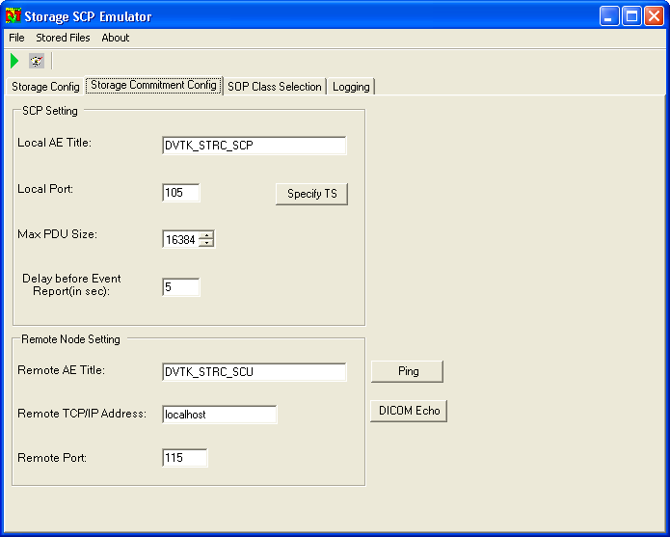

The Storage Commitment configuration includes:

- Local AE title
This is the AE title used by the SCP emulator to communicate with the storage commitment SCU node.

- Local port
The port used by the emulator to listen for incoming storage commitment associations. In the current version of the emulator, this port must be the same as the port used by the Storage SCP process. Therefore this port is not configurable in the Storage Commitment configuration screen.

- Max PDU Size
This is the Max PDU size proposed by the Storage Emulator SCP application to the SCU node. Default value is set to 16k

- Delay before Event Report (in sec)
This is the time that the SCP Emulator waits to sends the N-EVENT-REPORT-RQ message to the remote node. In case the SCU node has closed the Storage Commitment association before the N-EVENT-REPORT was sent, the emulator has to open a new association with the SCU.

- Remote AE title
AE title used by the Storage SCU node for incoming Storage Commitment messages.

- Remote IP address
IP address of the remote Storage Commitment SCU node.

- Remote port
Port number used by the Storage SCU node for incoming associations.

After the configuration parameters have been entered, the test buttons “Ping SCP” and “DICOM Echo” can be used to check if both the network and DICOM communication with the remote Storage Commitment node are working correctly.

Remark: All configuration settings for Storage and Storage commitment operation can be saved by using the File menu option “Config File, Save As”. The system writes the config settings into an xml file in a user defined location. With the “Config File, Load” function, the configuration file can be imported into the Storage SCP emulator again.

SOP Class selection
User can select the supported SOP Class for Storage SCP emulator before running the tool. It is a grid view control similar to DVT tool.
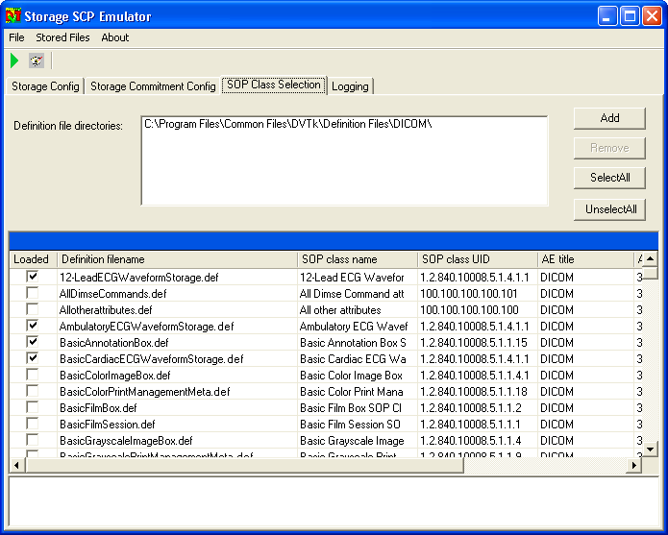

Logging

After the SCP emulator has been started, automatically the log window becomes active and shows the progress of the emulator operation.

An example of log information is given in the screen capture below:

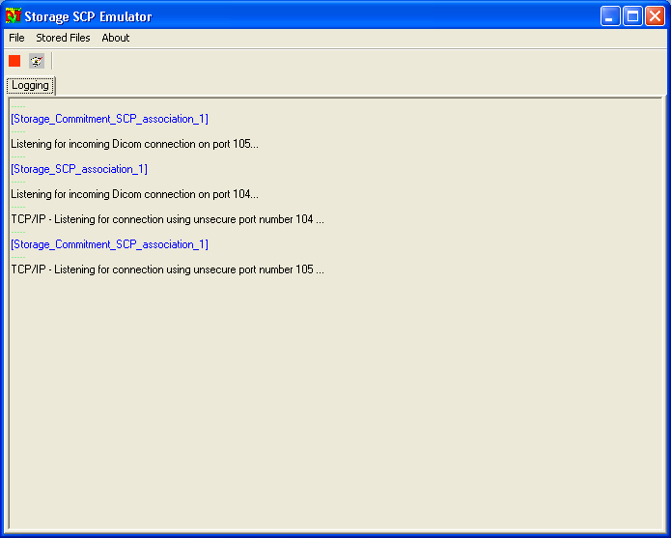

Validation results

In case the option Perform validation is enabled in the storage configuration screen, the validation results window is present after the emulator operation has been stopped.
The validation results of all received DICOM messages and data objects are displayed.

Validation results example:

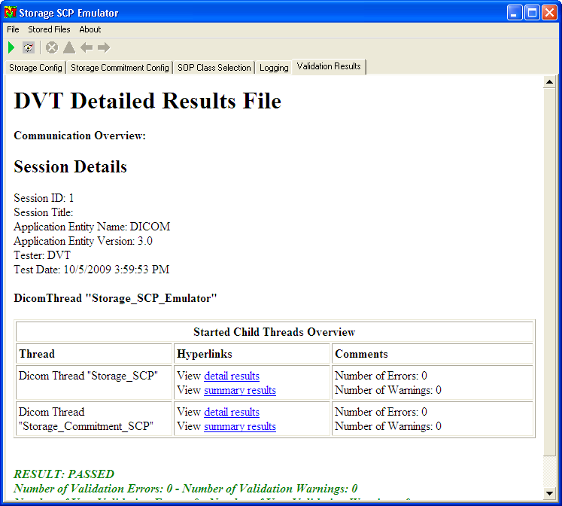

Store Files functionality

User can configure/explore the result and data directory for emulator by using this option. The screen shot is as shown below:
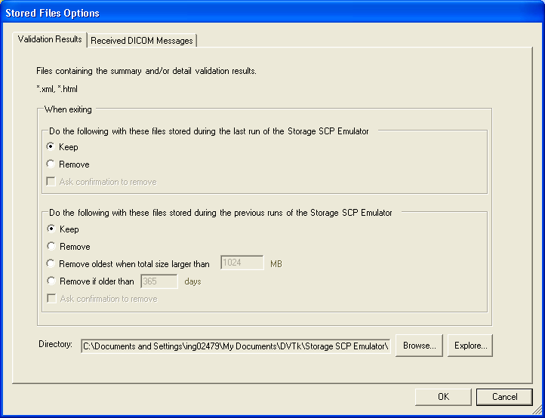

Validation Results Tab

With the “Browse” button, a directory can be selected for the storage of the result files.
The default result directory will be:
C:\Documents and Settings\ing02479\My Documents\DVTk\Storage SCP Emulator\Results

With the “Explore” button, Windows explorer is started and shows the contents of the result directory.

Received DICOM Messages Tab

With the “Browse” button, a directory can be selected for the storage of the received DICOM images. The default data directory will be:
C:\Documents and Settings\ing02479\My Documents\DVTk\Storage SCP Emulator\ Received DICOM Messages

With the “Explore” button, Windows explorer is started and shows the contents of the data directory (received DICOM files)

Cleanup of Result and Received DICOM message files

Various options are provided for storing old result (xml/html) files and DICOM message (dcm) files when application exits or for previous runs as shown in above screen shot.

Create DICOMDIR

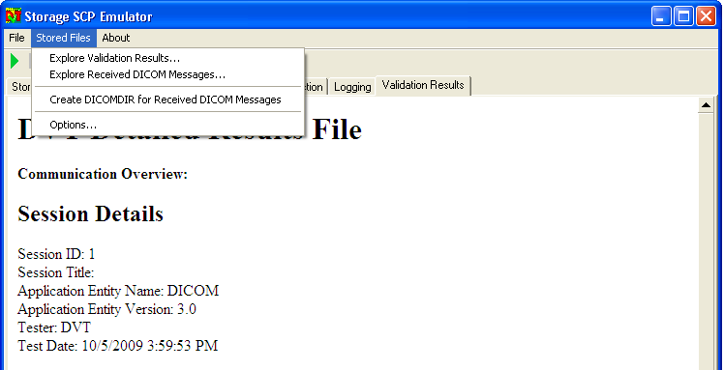

When selecting the menu option “Create DICOMDIR for Received DICOM Messages”, the emulator will create a DICOMDIR file for all DICOM images that are present in the configured data directory. All the DICOM files present in the “data directory” (including all sub-directories) are renamed and moved to a new directory called “DICOM” while the DICOMDIR file is saved in the “data directory”. All original files will be deleted.

Supported DICOM SOP classes

The DVT Storage SCP emulator supports the Storage SOP classes that are listed in the table below:

1.2.840.10008.5.1.4.1.1.1 | Computed Radiography Image Storage
1.2.840.10008.5.1.4.1.1.1.1 | Digital X-Ray Image Storage – For Presentation
1.2.840.10008.5.1.4.1.1.1.1.1 | Digital X-Ray Image Storage – For Processing
1.2.840.10008.5.1.4.1.1.1.2 | Digital Mammography X-Ray Image Storage – For Presentation
1.2.840.10008.5.1.4.1.1.1.2.1 | Digital Mammography X-Ray Image Storage – For Processing
1.2.840.10008.5.1.4.1.1.1.3 | Digital Intra-oral X-Ray Image Storage – For Presentation
1.2.840.10008.5.1.4.1.1.1.3.1 | Digital Intra-oral X-Ray Image Storage – For Processing
1.2.840.10008.5.1.4.1.1.2 | CT Image Storage
1.2.840.10008.5.1.4.1.1.2.1 | Enhanced CT Image Storage
1.2.840.10008.5.1.4.1.1.3 | Ultrasound Multi-frame Image Storage (Retired)
1.2.840.10008.5.1.4.1.1.3.1 | Ultrasound Multi-frame Image Storage
1.2.840.10008.5.1.4.1.1.4 | MR Image Storage
1.2.840.10008.5.1.4.1.1.4.1 | Enhanced MR Image Storage
1.2.840.10008.5.1.4.1.1.4.2 | MR Spectroscopy Storage
1.2.840.10008.5.1.4.1.1.5 | Nuclear Medicine Image Storage (Retired)
1.2.840.10008.5.1.4.1.1.6 | Ultrasound Image Storage (Retired)
1.2.840.10008.5.1.4.1.1.6.1 | Ultrasound Image Storage
1.2.840.10008.5.1.4.1.1.7 | Secondary Capture Image Storage
1.2.840.10008.5.1.4.1.1.7.1 | Multi-frame Single Bit Secondary Capture Image Storage
1.2.840.10008.5.1.4.1.1.7.2 | Multi-frame Grayscale Byte Secondary Capture Image Storage
1.2.840.10008.5.1.4.1.1.7.3 | Multi-frame Grayscale Word Secondary Capture Image Storage
1.2.840.10008.5.1.4.1.1.7.4 | Multi-frame True Color Secondary Capture Image Storage
1.2.840.10008.5.1.4.1.1.8 | Standalone Overlay Storage (Retired)
1.2.840.10008.5.1.4.1.1.9 | Standalone Curve Storage (Retired)
1.2.840.10008.5.1.4.1.1.9.1.1 | 12-lead ECG Waveform Storage
1.2.840.10008.5.1.4.1.1.9.1.2 | General ECG Waveform Storage
1.2.840.10008.5.1.4.1.1.9.1.3 | Ambulatory ECG Waveform Storage
1.2.840.10008.5.1.4.1.1.9.2.1 | Hemodynamic Waveform Storage
1.2.840.10008.5.1.4.1.1.9.3.1 | Cardiac Electrophysiology Waveform Storage
1.2.840.10008.5.1.4.1.1.9.4.1 | Basic Voice Audio Waveform Storage
1.2.840.10008.5.1.4.1.1.10 | Standalone Modality LUT Storage (Retired)
1.2.840.10008.5.1.4.1.1.11 | Standalone VOI LUT Storage (Retired)
1.2.840.10008.5.1.4.1.1.11.1 | Grayscale Softcopy Presentation State Storage SOP Class
1.2.840.10008.5.1.4.1.1.12.1 | X-Ray Angiographic Image Storage
1.2.840.10008.5.1.4.1.1.12.2 | X-Ray Radiofluoroscopic Image Storage
1.2.840.10008.5.1.4.1.1.12.3 | X-Ray Angiographic Bi-Plane Image Storage (Retired)
1.2.840.10008.5.1.4.1.1.20 | Nuclear Medicine Image Storage
1.2.840.10008.5.1.4.1.1.66 | Raw Data Storage
1.2.840.10008.5.1.4.1.1.66.1 | Spatial Registration Storage
1.2.840.10008.5.1.4.1.1.66.2 | Spatial Fiducials Storage
1.2.840.10008.5.1.4.1.1.77.1 | VL Image Storage (Retired)
1.2.840.10008.5.1.4.1.1.77.2 | VL Multi-frame Image Storage (Retired)
1.2.840.10008.5.1.4.1.1.77.1.1 | VL Endoscopic Image Storage
1.2.840.10008.5.1.4.1.1.77.1.1.1 | Video Endoscopic Image Storage
1.2.840.10008.5.1.4.1.1.77.1.2 | VL Microscopic Image Storage
1.2.840.10008.5.1.4.1.1.77.1.2.1 | Video Microscopic Image Storage
1.2.840.10008.5.1.4.1.1.77.1.3 | VL Slide-Coordinates Microscopic Image Storage
1.2.840.10008.5.1.4.1.1.77.1.4 | VL Photographic Image Storage
1.2.840.10008.5.1.4.1.1.77.1.4.1 | Video Photographic Image Storage
1.2.840.10008.5.1.4.1.1.77.1.5.1 | Ophthalmic Photography 8 Bit Image Storage
1.2.840.10008.5.1.4.1.1.77.1.5.2 | Ophthalmic Photography 16 Bit Image Storage
1.2.840.10008.5.1.4.1.1.77.1.5.3 | Stereometric Relationship Storage
1.2.840.10008.5.1.4.1.1.88.11 | Basic Text SR
1.2.840.10008.5.1.4.1.1.88.22 | Enhanced SR
1.2.840.10008.5.1.4.1.1.88.33 | Comprehensive SR
1.2.840.10008.5.1.4.1.1.88.50 | Mammography CAD SR
1.2.840.10008.5.1.4.1.1.88.59 | Key Object Selection Document
1.2.840.10008.5.1.4.1.1.88.65 | Chest CAD SR
1.2.840.10008.5.1.4.1.1.104.1 | Encapsulated PDF Storage
1.2.840.10008.5.1.4.1.1.128 | Positron Emission Tomography Image Storage
1.2.840.10008.5.1.4.1.1.129 | Standalone PET Curve Storage (Retired)
1.2.840.10008.5.1.4.1.1.481.1 | RT Image Storage
1.2.840.10008.5.1.4.1.1.481.2 | RT Dose Storage
1.2.840.10008.5.1.4.1.1.481.3 | RT Structure Set Storage
1.2.840.10008.5.1.4.1.1.481.4 | RT Beams Treatment Record Storage
1.2.840.10008.5.1.4.1.1.481.5 | RT Plan Storage
1.2.840.10008.5.1.4.1.1.481.6 | RT Brachy Treatment Record Storage
1.2.840.10008.5.1.4.1.1.481.7 | RT Treatment Summary Record Storage
1.2.840.10008.1.20.1 | Storage Commitment Push model

Table 4-1 supported Storage SOP classes

Supported transfer syntaxes

In the table below, all transfer syntaxes are listed that are supported by the SCP emulator.
The bold printed transfer syntaxes are supported by default, the other transfer syntaxes can be enabled in the Storage SCP application.

UID Value | UID Name
1.2.840.10008.1.2 | Implicit VR Little Endian
1.2.840.10008.1.2.1 | Explicit VR Little Endian
1.2.840.10008.1.2.2 | Explicit VR Big Endian
1.2.840.10008.1.2.4.50 | JPEG Baseline (Process 1)
1.2.840.10008.1.2.4.51 | JPEG Extended (Process 2 & 4)
1.2.840.10008.1.2.4.52 | JPEG Extended (Process 3 & 5)
1.2.840.10008.1.2.4.53 | JPEG Spectral Selection, Non-  Hierarchical (Process 6 & 8)
1.2.840.10008.1.2.4.54 | JPEG Spectral Selection, Non-  Hierarchical (Process 7 & 9)
1.2.840.10008.1.2.4.55 | JPEG Full Progression, Non-  Hierarchical (Process 10 & 12)
1.2.840.10008.1.2.4.56 | JPEG Full Progression, Non-  Hierarchical (Process 11 & 13)
1.2.840.10008.1.2.4.57 | JPEG Lossless, Non-Hierarchical  (Process 14)
1.2.840.10008.1.2.4.58 | JPEG Lossless, Non-Hierarchical  (Process 15)
1.2.840.10008.1.2.4.59 | JPEG Extended, Hierarchical  (Process 16 & 18)
1.2.840.10008.1.2.4.60 | JPEG Extended, Hierarchical  (Process 17 & 19)
1.2.840.10008.1.2.4.61 | JPEG Spectral Selection,  Hierarchical (Process 20 & 22)
1.2.840.10008.1.2.4.62 | JPEG Spectral Selection,  Hierarchical (Process 21 & 23)
1.2.840.10008.1.2.4.63 | JPEG Full Progression,  Hierarchical (Process 24 & 26)
1.2.840.10008.1.2.4.64 | JPEG Full Progression,  Hierarchical (Process 25 & 27)
1.2.840.10008.1.2.4.65 | JPEG Lossless, Hierarchical  (Process 28)
1.2.840.10008.1.2.4.66 | JPEG Lossless, Hierarchical  (Process 29)
1.2.840.10008.1.2.4.70 | JPEG Lossless, Non-Hierarchical,  First-Order Prediction (Process 14)
1.2.840.10008.1.2.4.80 | JPEG-LS Lossless Image  Compression
1.2.840.10008.1.2.4.81 | JPEG-LS Lossy (Near-Lossless)  Image Compression
1.2.840.10008.1.2.4.90 | JPEG 2000 Image Compression  (Lossless Only)
1.2.840.10008.1.2.4.91 | JPEG 2000 Image Compression
1.2.840.10008.1.2.4.92 | JPEG 2000 Part 2 Multi-component  Image Compression
1.2.840.10008.1.2.4.93 | JPEG 2000 Part 2 Multi-component  Image Compression
1.2.840.10008.1.2.4.94 | JPIP Referenced
1.2.840.10008.1.2.4.95 | JPIP Referenced Deflate
1.2.840.10008.1.2.4.100 | MPEG2 Main Profile
1.2.840.10008.1.2.4.101 | MPEG2 Main Profile / High Level
1.2.840.10008.1.2.4.102 | MPEG-4 AVC/H.264 High Profile / Level 4.1
1.2.840.10008.1.2.4.103 | MPEG-4 AVC/H.264 BD-compatible High Profile / Level 4.1
1.2.840.10008.1.2.4.104 | MPEG-4 AVC/H.264 High Profile / Level 4.2 For 2D Video
1.2.840.10008.1.2.4.105 | MPEG-4 AVC/H.264 High Profile / Level 4.2 For 3D Video
1.2.840.10008.1.2.4.106 | MPEG-4 AVC/H.264 Stereo High Profile / Level 4.2
1.2.840.10008.1.2.4.107 | HEVC/H.265 Main Profile / Level 5.1
1.2.840.10008.1.2.4.108 | HEVC/H.265 Main 10 Profile / Level 5.1
1.2.840.10008.1.2.6.1 | RFC 2557 MIME encapsulation
1.2.840.10008.1.2.6.2 | XML Encoding
1.2.840.10008.1.2.5 | RLE Lossless
1.2.840.10008.1.2.1.99 | Deflated Explicit VR Little Endian

Table 5-1: Supported transfer syntaxes

